5.2 The significance of technology

The Australian work environment has changed significantly in the past two decades. Much of this change can be attributed to the development of technology and rapid communications advances that have altered the way the world does business.

**Significant technological change**

The world of work changed dramatically in the late 1980s with the development of the desktop computer, but it was the invention of the internet in the 1990s that has brought arguably the greatest change to the world of work since the Industrial Revolution. The internet, computers and devices such as smart phones and tablets are now part of our everyday life and, for most workers, have been integrated significantly into the way that they undertake and complete their work. The ability to communicate virtually instantaneously with anyone almost anywhere in the world has changed the way people do business and has been a major factor in the process of globalisation.

**Types of new technology**

Technological advances have changed many aspects of business operation, from administration tasks to internal and external communications and service provision and manufacturing processes. The list of technological advances that have changed the way we work is enormous. It includes:

* Video conferencing and webinars: using technology to meet or conduct information and training sessions, rather than needing to have face-to-face interactions
* Smart technology (smart phones): enabling 24/7 communication through phone, email, SMS, MMS
* eCommerce: internet banking, online shopping, EFTPOS, Paypass
* Software developments: word processing, spreadsheets, database, accounting and other software programs that streamline administrative tasks
* Robotics and their use in manufacturing, especially in assembly lines
* Computer-aided design (CAD): using computers to design new products, buildings etc.
* Computer-aided manufacturing (CAM): using computers to assist with the manufacturing process of goods and services
* Cloud computing: external data storage away from the organisation, allowing access to information from anywhere
* Communication: discussion forums, blogs, social networking – creating new ways to reach potential customers  *F*

*IGURE 1* 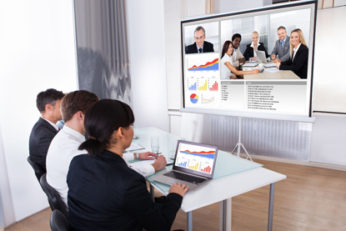

Video conferencing allows workers to meet even though they may be in different countries.

**How technology has changed working lives**

The impact of technological advances has been felt significantly in the workplace. For example, where once it was necessary to send written materials via the post (which may take several days or even weeks to be delivered, depending on the distances involved) email now makes it possible for correspondence to be sent and delivered within the same minute! Computer software enables once tedious administrative, accounting and other processes to be completed in a fraction of the time that they once required. And computer-operated machines now perform many manufacturing line tasks that once required meticulous human completion. Similarly, in many cases where once manual labour was the norm, computers and robots now control the lifting and movement of heavy objects. Interestingly, the law has followed this process and various requirements have been introduced that seek to protect workers and ensure that employers provide a safe environment for them. Occupational (Workplace) Health and Safety laws exist covering issues such as manual handling, machine operation, safety guards and shut-off mechanisms, acceptable noise levels, and other hazard management in relation to the use of technology in the workplace.

**Manufacturing**

The use of computers in production has meant that the manufacturing process has sped up significantly and, in turn, productivity levels have increased. Assembly lines, computer-aided designs, and computer-driven manufacturing processes (in which computers control and direct the machinery and equipment), have meant that less workers are needed to undertake the manual aspects of production. However, the increase in production output, combined with access to new markets through globalised trade opportunities has allowed the growth of some businesses, and a need for increased numbers of workers to meet the demands of expansion. Further, the nature of many roles in computer-assisted manufacturing operations has changed, with workers gaining higher level skills as they are trained to be able to monitor equipment and carry out any adjustments or even repairs that may be required.

*FIGURE*

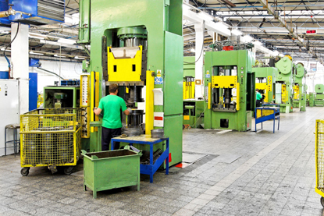

*2* The types of machinery used in manufacturing processes are constantly changing the way workers work and the work that they do.

**Rapid communication changes**

Technology has changed the concept of communication. For example, the growth of the internet has meant that news events, when they occur, can be instantly disseminated and shared through instant messaging, blogs, emails, and websites. This change has had a huge impact on print media such as newspapers. Many people no longer buy the printed newspaper but will instead read the news online — and it is not just local newspapers that they can access, but also newspapers from around the world.

In the workplace, these rapid changes have led to enormous shifts in the way people communicate and work. No longer is there a need to have ‘face time’, where people need to be in the same room to meet and discuss business. As figure 1 depicts, face time has been replaced by ‘virtual meeting time’. Smart devices allow for instant communication and access to workers, employers, suppliers and producers.

Where once distance may have been a prohibitive factor in applying for and obtaining a job, this is no longer the case. In many fields of work, employees increasingly have the opportunity to work remotely, based from their own homes. The use of technology such as tele- or video-conferencing, email, cloud computing and so on effectively eliminates the distance between people, and creates opportunities for more flexible work arrangements that are beneficial for both the employee and the employer.